Abstract Class
The Rules of Abstract Methods
- No Body: Abstract methods end with a semicolon ; instead of curly braces {}.
- The abstract Keyword: You must place the word abstract before the method name.
- Abstract Class Requirement: If a class contains even one abstract method, the entire class must be declared as abstract. You cannot instantiate (create a new) abstract class directly.
- Child Obligation: Any normal child class that inherits from an abstract parent must override and write the body for all abstract methods, or your code will fail to compile.
The Abstract Parent Class
Traditional gas car accelerates by burning fuel, while an electric car accelerates by pulling power from a battery pack. Instead of writing a generic, useless default method in the parent class, we make it abstract.

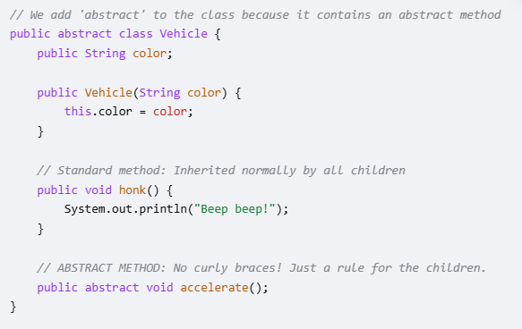
The Child Classes (Fulfilling the Contract)
Now, any child class that extends Vehicle is forced by Java to implement accelerate(). If you forget to add it, Java will give you a compilation error.

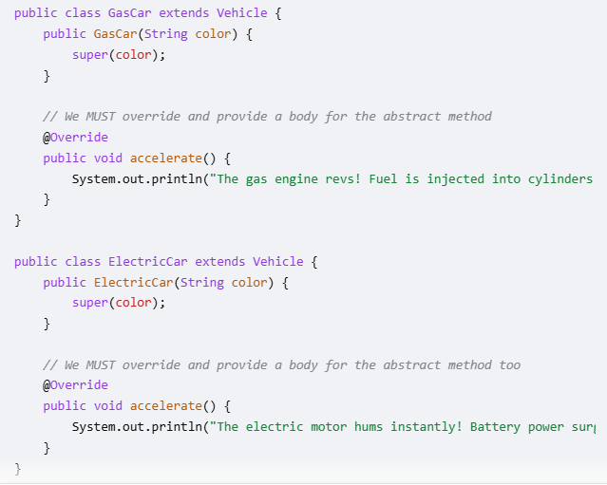
Running the Code in Main
Remember, you cannot do Vehicle v = new Vehicle("Red"); because abstract classes are incomplete blueprints. You can only instantiate the concrete children.

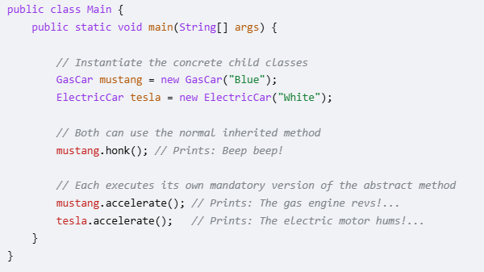

Why Use Abstract Methods?

Abstract methods allow you to enforce a standard design structure across multiple different classes. It guarantees that no matter what kind of vehicle someone programs in the future, it is guaranteed to have an accelerate() action built into it.

